**ENVIRONMENTAL IMPACT OF REPLACING PLASTICS with BAMBOO USING PYTHON PROGRAMMING**

**INTRODUCTION:**

* Plastic usage is widespread in the packaging, aerospace, marine, and automobile industries because of their lightweight, low manufacturing costs.
* The storage capacity of non-renewable resources such as oil, coal and natural gas.
* Bamboo with its unique properties and environmental benefits, has emerged as a promising substitute.
* Reduced plastic pollution, renewable resource usage, carbon sequestration, energy consumption, biodiversity conservation, and chemical pollution reduction
* The geographical distribution of bamboo in the world can be divided into three major bamboo regions
* Asia-Pacific Bamboo Region
* Americas Bamboo Region
* Africa Bamboo Region
* The main bamboo-producing countries include China, India, Thailand, Myanmar, Bangladesh, etc,.
* The same area of bamboo forest can release 35% more oxygen than a forest.
* The use of bamboo as a renewable resource to reduce plastic pollution
* Natural fiber-reinforced composites have become a hot research topic due to their environmental friendliness and high performance
* Glass fiber is light in quality, has good tensile strength, and has excellent performance in electric insulation, high temperature resistance, flame retardance and heat insulation
* Synthetic fiber composites such as carbon fiber, basalt fiber, and glass fiber are widely used in aerospace, construction, marine and other fields due to their excellent performance

**ABSTRACT:**

* Natural fibers, bamboo is characterized by fast growth, a short cultivation period, high strength and good toughness, and is one of the strongest natural fibers in the world
* In addition to their environmental protection and green production
* Mechanical properties of bamboo-fiber-reinforced thermoplastic composites
* High-performance bamboo fiber to minimize plastic pollution
* Structural features conferred excellent strength, water resistance, oil resistance, better high- and low-temperature resistance
* That replacing 20% of plastic tableware products with the bamboo fiber
* Equal to reducing carbon emissions equivalent to 300,000 cars in a small city.

Keywords: bamboo fiber, plastic, natural, mechanical

**PRIMARY OBJECTIVES:**

* Environmental Sustainability: Bamboo is biodegradable and renewable, making it a more environmentally friendly alternative to plastic.
* Plastic Pollution Reduction: Substituting plastic with bamboo helps reduce the amount of plastic waste entering landfills and natural environments.
* Resource Conservation: Bamboo requires fewer resources to grow and harvest compared to the production of plastic.
* Carbon Footprint Reduction: Bamboo has a lower carbon footprint than plastic due to its ability to sequester carbon dioxide during growth.
* Promotion of Sustainable Practices: Embracing bamboo as an alternative to plastic encourages the adoption of more sustainable manufacturing and consumption practices.
* Diverse Applications: Bamboo can be used in various products and industries, including packaging, construction materials, textiles, utensils.

**SECONDARY OBJECTIVES:**

* Renewability: Bamboo is a highly renewable resource as it grows rapidly, sometimes up to several feet in a single day, and can be harvested annually without causing damagee to the environment.
* Biodegradability: Unlike plastic, which can take hundreds of years to decompose, bamboo is biodegradable
* Low Environmental Impact: Bamboo cultivation typically requires minimal water, no pesticides, and no fertilizers, making it a more environmentally friendly option compared to the production of plastic.
* Strength and Durability: Bamboo fibers are known for their strength and durability, making bamboo-based products a viable alternative to traditional plastic items.
* Carbon Sequestration: Bamboo plants absorb large amounts of carbon dioxide from the atmosphere, helping to mitigate climate change by acting as a carbon sink.
* Consumer Demand: There is a growing demand among consumers for sustainable and eco-friendly products, driving businesses to seek alternatives to plastic, with bamboo emerging as a popular choice.

**Advantages:**

* Plastic is light in weight.
* Plastic is cheap to produce.
* Plastic bottles can be restored and reused over again and again.
* Fast growing
* High productive
* Light, Strong and Versatile.

**DISADVANTAGES:**

* The recycling process is very costly.
* Plastic causes cancer.
* Plastic show deformation under load.
* Plastic is soft.
* Bamboo shrinks much greater as compared to other types of materials
* Bamboo may absorb water during the casting and [curing](https://civiljungle.com/concrete-cure-time/) of the concrete.
* If the bamboo is not sufficiently treated it may undergo the fungus attack or attacks caused by insects.

**FUNCTIONAL REQUIREMENTS:**

* Transportation-Analyze carbon footprint of transportation.
* Product End-of-Life-Assess disposal methods and environmental impact.
* Social and Economic Impacts-Evaluate social and economic implications.
* Regulatory Compliance-Ensure compliance with environmental regulations.
* Stakeholder Engagement-Engage with stakeholders for input and concerns.

**ARCHITECTURE DIAGRAM:**

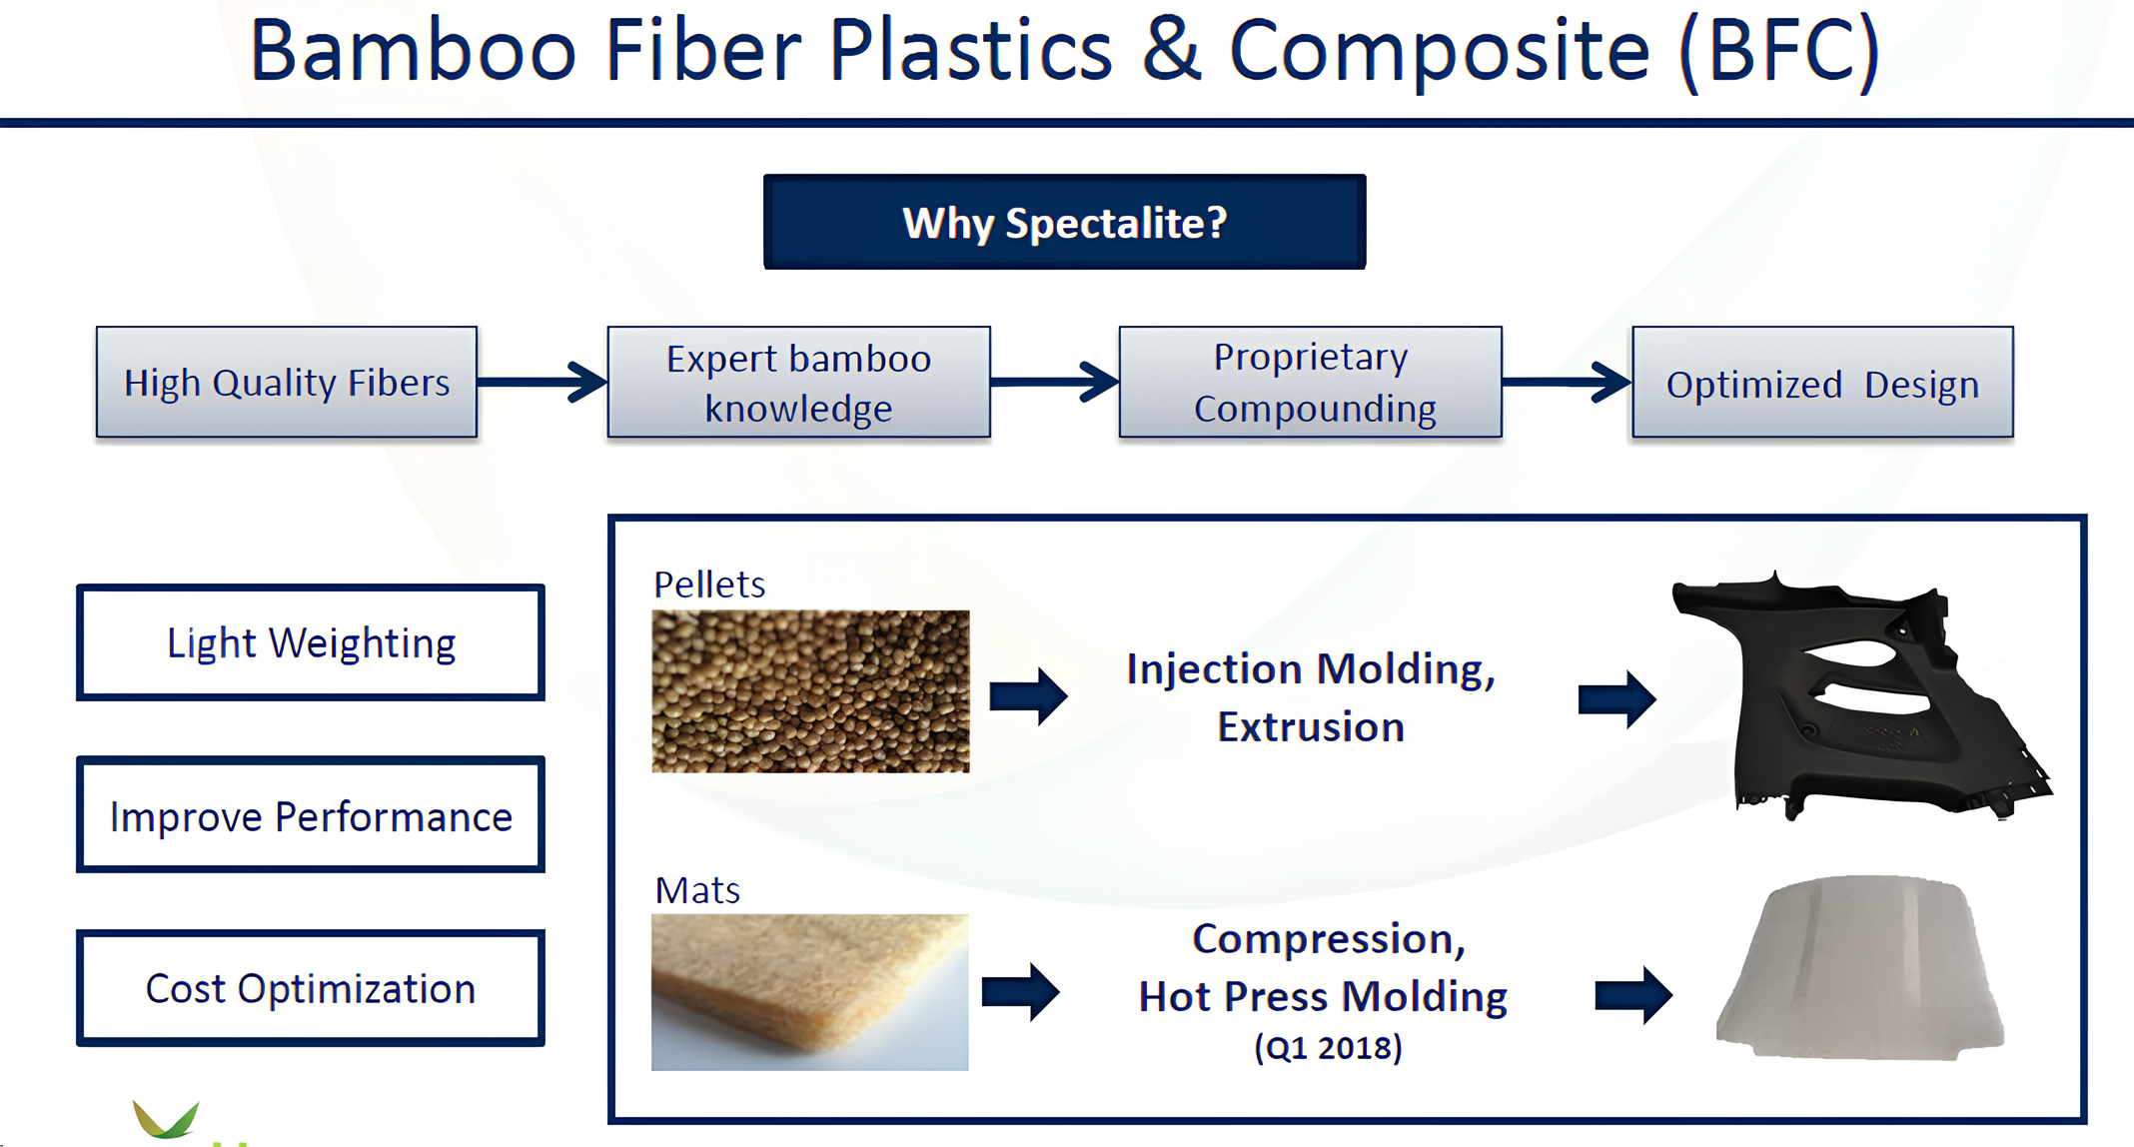

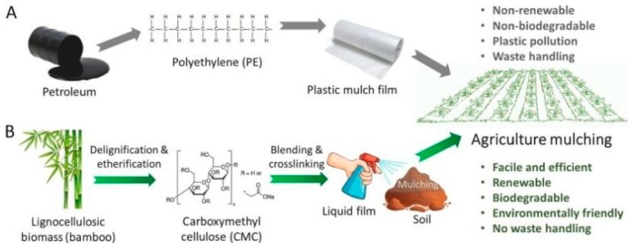

**CODING:**

carbon_footprint_plastics = 10

carbon_footprint_bamboo =2

plastics_production = 1000

bamboo_production = 1000

total_carbon_plastics = carbon_footprint_plastics * plastics_production

total_carbon_bamboo = carbon_footprint_bamboo * bamboo_production

print("Total carbon footprint for producing plastics:", total_carbon_plastics, "kg CO2 equivalents")

print("Total carbon footprint for producing bamboo-based products:", total_carbon_bamboo, "kg CO2 equivalents")

carbon_footprint_reduction = total_carbon_plastics - total_carbon_bamboo

print("By replacing plastics with bamboo, you would reduce carbon footprint by:", carbon_footprint_reduction, "kg CO2 equivalents")

OUTPUT:

Total carbon footprint for producing plastics: 10000 kg CO2 equivalents

Total carbon footprint for producing bamboo-based products: 2000 kg CO2 equivalents

By replacing plastics with bamboo, you would reduce carbon footprint by: 8000 kg CO2 equivalents

**CONCLUSION:**

* Replacing plastics with bamboo can have several positive environmental impacts.
* Bamboo is a renewable resource that grows quickly and requires fewer resources to cultivate compared to many plants used for plastic production.
* By utilizing bamboo-based products, we can reduce plastic pollution, decrease our reliance on fossil fuels, and mitigate the carbon footprint associated with traditional plastic manufacturing processes.
* Natural bamboo fiber has many advantages such as a large aspect ratio, high specific strength, large surface area, low density, and being inexpensive, renewable and biodegradable
* Environmental protection and density.
* Achieve “replacing plastics with bamboo” to promote the green development of the economy.
* The development and preparation of environmentally friendly and biodegradable BFRPC using bamboo fibers as reinforcement and biodegradable polymers as substrate has become a hot research topic

**REFERENCES:**

1. Chen, Y.; Awasthi, A.K.; Wei, F.; Tan, Q.Y.; Li, J.H. Single-use plastics: Production, usage, disposal, and adverse impacts. Sci. Total Environ. 2021, 752, 141772. [Google Scholar] [CrossRef] [PubMed].
2. Williams, A.T.; Rangel-Buitrago, N. The past, present, and future of plastic pollution. Mar. Pollut. Bull. 2022, 176, 113429. [Google Scholar] [CrossRef] [PubMed].
3. Opeyemi, B.M. Path to sustainable energy consumption: The possibility of substituting renewable energy for non-renewable energy. Energy 2021, 228, 120519. [Google Scholar] [CrossRef].
4. .Xian, G.; Guo, R.; Li, C. Combined effects of sustained bending loading, water immersion and fiber hybrid mode on the mechanical properties of carbon/glass fiber reinforced polymer composite. Compos. Struct. 2022, 281, 115060. [Google Scholar] [CrossRef.]
5. Stalin, A.; Mothilal, S.; Vignesh, V.; Sanjay, M.R.; Siengchin, S. Mechanical properties of hybrid vetiver/banana fiber mat reinforced vinyl ester composites. J. Ind. Text. 2022, 51, 5869S–5886S. [Google Scholar] [CrossRef]
6. Amin M., Shah H.H., Fareed A.G., Khan W.U., Chung E.H.Y., Zia A., Farooqi Z.U.R., Lee C.H.Y. Hydrogen production through renewable and non-renewable energy processes and their impact on climate change. Int. J. Hydrogen Energy. 2022;47:33112–33134. doi: 10.1016/j.ijhydene.2022.07.172.